

*‘The Joy of Fresh Herbs’*

*Group 10*

|  |  |
| --- | --- |
| **Institute of Engineering & Transport** | **Institute of ICT** |
|  |  |
| Luke Camilleri – BEEC1 | Paul Muscat - MSD6.2A |
| Ben Farrugia – BEEC1 | Maria Grech - MSD6.2B |
| Owen Buttigieg – BEE1 | Danica Fiteni - MSD6.2B |
| Chris Saliba – BEEC1 |  |

1. Executive Summary 3

2. Business Overview 4

2.1 Description of Product / Service 4

2.2 Legal Considerations 7

3. Market Analysis 8

3.1 Market Gap 8

3.2 Competitor Analysis 9

3.3 Identified Target Audience 9

3.4 Primary Research Results 10

3.5 Interpretation of Research Results and Concluding Remarks 20

4. SWOT Analysis 23

5. Marketing Plan 24

5.1 Branding 24

5.2 Monthly Marketing Budget 25

5.3 Pricing Strategy 26

5.4 Physical Location and Distribution Channels 27

5.5 Promotional Plans 28

6.Organisation 29

6.1 Business Legal Format 29

6.2 Organization Chart and Key Responsibilities 29

7. Operating Plan 30

7.1 Development Timeline 30

7.2 Operations Flow 31

7.3 Resources Required 33

8. Financial Planning 34

8.1 Sales Forecast 34

8.2 Cash Flow Forecast 35

8.3 Funding Requirements 36

9.Appendices 37

9.1 Questionnaire / Interviews 37

9.2 Quotations for Resources Required 46

9.5 Other 48

10. References 49

# Executive Summary

Smart Kitchen Garden is an innovative venture that aims to transform home gardening by integrating technology and sustainable farming practices. Our mission is to empower individuals to cultivate fresh, organic produce in their own kitchens, contributing to healthier lifestyles and a more sustainable future.

The market for home gardening and sustainable food is rapidly expanding, driven by increased health consciousness and a desire for locally sourced, pesticide-free produce for those who do not have the space or gardens in their homes. Herb Garden Ltd intends to enter this expanding market by offering a convenient and efficient solution for apartment owners, and individuals with limited gardening space.

Our Smart Kitchen Garden system is a compact and modular unit that combines automated LED lighting, automated watering system, and a user-friendly mobile app. Our system optimizes plant growth conditions and allows users to monitor and control their garden remotely by leveraging smart sensors and data analytics. Our seeds are packaged in nutrient-rich biodegradable plant pods. Fresh herbs and plants available in the pods include basil, oregano, mint, and parsley.

One of our key competitive advantages is the incorporation of full spectrum lighting into our gardening system, which can be controlled via our mobile app. It also has an automatic LED timing system that allows the lights to turn on and off automatically. The seeds are packaged in nutrient-rich biodegradable plant pods. Furthermore, the device is portable and can be charged whenever it is needed.

One of our major competitors in the market is Click & Grow, a company that offers a wide range of smart gardening devices in many sizes. They also provide a subscription service with different pricing tiers. Additionally, we face competition from local vegetable trucks and grocery stores that sell individual herbs and produce.

Herbs Garden Ltd also conducted a questionnaire achieving 152 responses resulting that 82.8% of the participants are willing to purchase a product like ours. These results indicate an elevated level of interest among respondents, indicating an excellent market reception for our product.

The business is owned by 7 shareholders each sharing an equity of 14.3%. Herb Garden Ltd is aiming to start selling products in January 2024 and forecasts €76,270 in sales during the year 2024. Based on the business plan, a total of €66,200 funding is needed. This will be obtained via the owner’s personal investment in the business. A €20,000 government fund is also being applied for.

In conclusion, Smart Kitchen Garden offers a transformative solution for home gardening, allowing individuals to grow fresh, organic produce in their own kitchens.

# Business Overview

## 2.1 Description of Product / Service

Our product is a portable smart kitchen garden. We offer biodegradable plant pods that contain seeds and nutrients, allowing you to enjoy homegrown food all year. The pods come in a variety of herbs and plants including fresh herbs like basil, oregano, mint, and parsley. Our product also offers automatic lighting and watering system, which can be monitored via our mobile app.

Our product will be provided with pods; however, customers will need to purchase new pods after a maximum of 6 months because the herb will no longer be edible.

Our products will come in a variety of sizes. We have two pods, three pods, four pods, six pods, and eight pods. We want to produce these sizes to satisfy our consumers.

* **USP – Unique Selling Proposition**

Some of our product's unique features are as follows:

The device includes full-spectrum lighting that can be controlled via our mobile app. The device is portable and can be charged whenever it is required. It also has an automatic timing system for LEDs, which allows the lights to be turned on and off automatically. The seeds are packaged in biodegradable plant pods that contain nutrients.

* **Images of Concept Prototype**

‘Fusion 360’ was used to design the product. The following screenshots are taken from the software.

Fig. 1 - Exploded View of Prototype

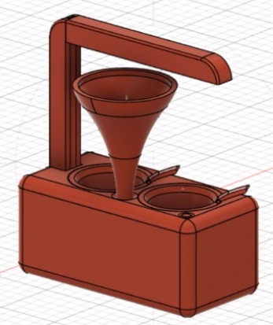

Fig. 2 - Smart Kitchen Garden Model

After printing all the parts of the product, everything was assembled together. The components and pods were also fitted in, finalising the product.

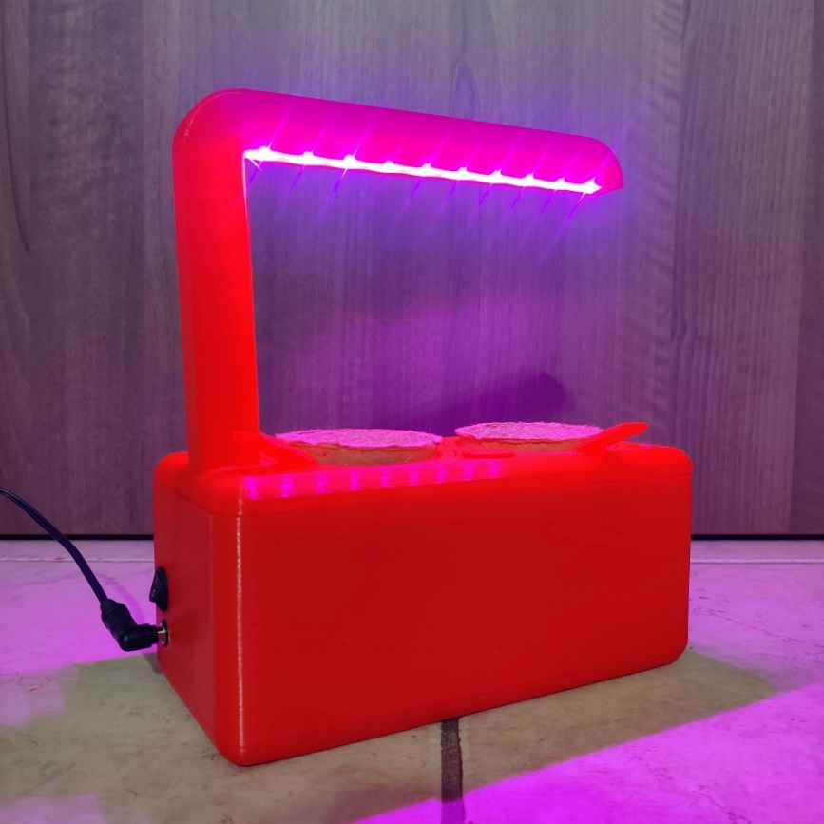

Fig. 3 - Assembled Product

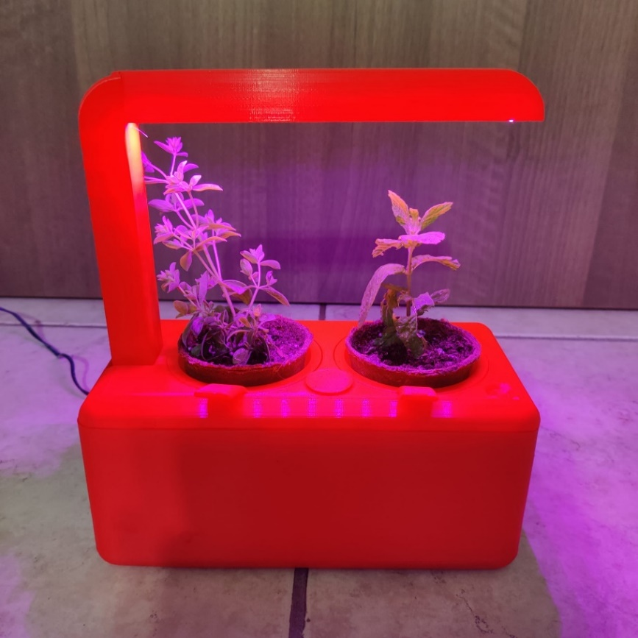

Fig. 4 - Assembled device with plants

* **Describe Intellectual Property related to your business**

'Herb Garden Ltd.’ has developed unique technology for our smart kitchen garden products, which allow our users to control their device watering, lighting, and temperature of their plants remotely through our mobile app.

As a company we could file a patent to protect this technology from being copied or used by competitors. We can also register a trademark for our brand logo, name, and slogan. By doing this, we will obtain copyright protection for our content/material.

By doing all of this, 'Herb Garden Ltd.' can prevent other companies and individuals from using our content and products without permission. We will establish an identity for our business market.

## 2.2 Legal Considerations

Industry-specific regulations:

Our company will source plant pods that abide by the European Union’s Standards for Composability EN13432:2000 (European Committee for Standardization,2000).

To ensure our biodegradable pods are up to standard, we will need to find a manufacturer that has the proper product certifications.

Sourcing certified biodegradable pods, ensuring their quality and performance may incur a higher cost for the company compared to the traditional plastic packaging.

# Market Analysis

## 3.1 Market Gap

* What is the gap in the market that you are trying to fill?

The gap consists of people who would like to grow their own fresh herbs but do not have the space or gardens in their homes.

|  |  |  |  |  |  |  |  |
| --- | --- | --- | --- | --- | --- | --- | --- |
|  | **High Quality** | | | | | |  |
| **Low Price** |  |  |  |  |  |  | **High Price** | |
|  |  |  | Click & Grow |  |  |
|  |  | **Herb Garden Ltd.** |  | Veritable |  |
|  | Local Grocery Store | AeroGarden | iDOO |  |  |
|  |  |  |  |  |  |
|  |  |  |  |  |  |
|  | **Low Quality** | | | | | |  |

## 3.2 Competitor Analysis

* Who are your competitors, and which other alternative products / services are currently available?

One of our biggest competitors is ‘Click & Grow’ and ‘Veritable’ which offer a wide variety of assorted sizes of this device. 'Click & Grow’ also offer a subscription with different values. Other competitors such as vegetable trucks and groceries which sell individual herbs are also competitors to us.

|  |  |  |  |
| --- | --- | --- | --- |
| **Factors** | **Click and Grow** | **Veritable** | **Herb Garden Ltd.** |
| **Quality** | Excellent | Good | Moderate |
| **Price** | Moderate | Good | Excellent |
| **Location** | Good | Good | Good |
| **Selection** | Excellent | Fair | Good |
| **Customer Service** | Moderate | Moderate | Excellent |
| **Specialization** | Good | Good | Good |
| **Personalisation** | Good | Moderate | Excellent |

* Where do you position your business when compared to competitors?

Our company is different from others because our product is portable and specifies on certain herbs. Our device is also designed to be small to fit in a cupboard or tight areas. Full spectrum lighting is also used in the devices in order to grow the herbs faster.

## 3.3 Identified Target Audience

The customers that we are targeting are people who own apartments and houses with no garden that would like to grow their own fresh herbs to use while cooking at home. This audience includes people with a fast life that do not have the time to take care of their herbs. That is why our product does not require a lot of attention as it is easy and automatic to use.

## 3.4 Primary Research Results

A survey was conducted online gaining 152 responses. We mainly sent this questionnaire to our families and friends that live in apartments, and do not have gardens in their houses.

A blank copy of the questionnaire can be found in the appendices section of the document.

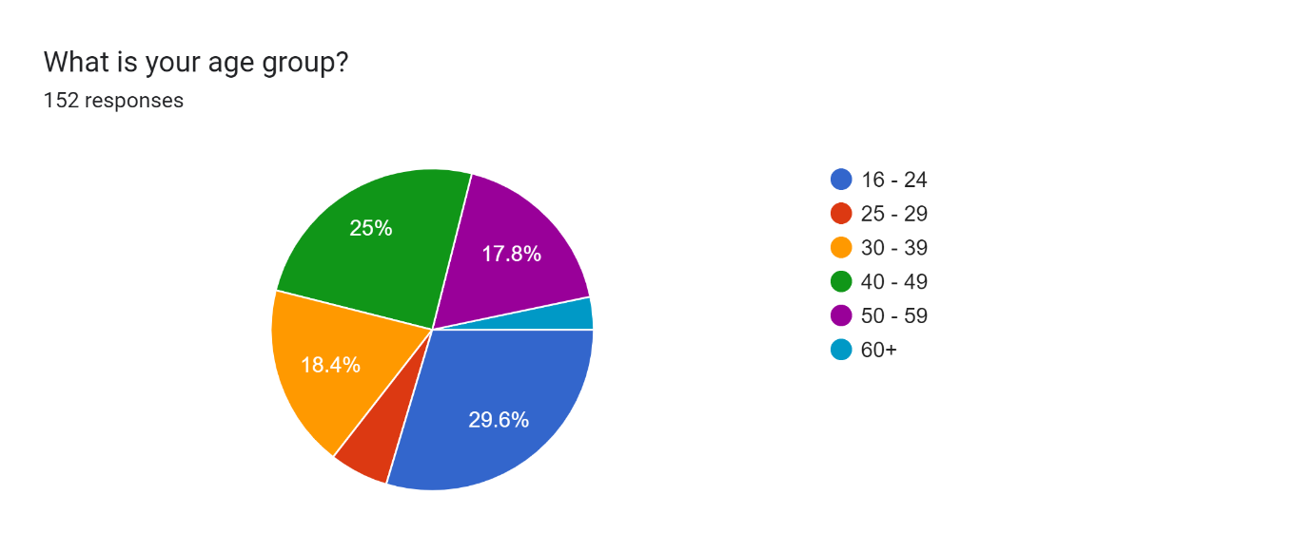

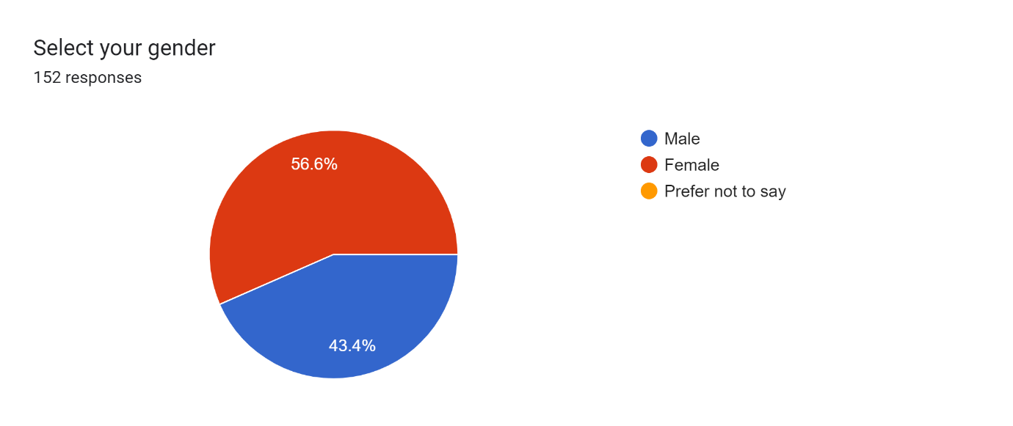

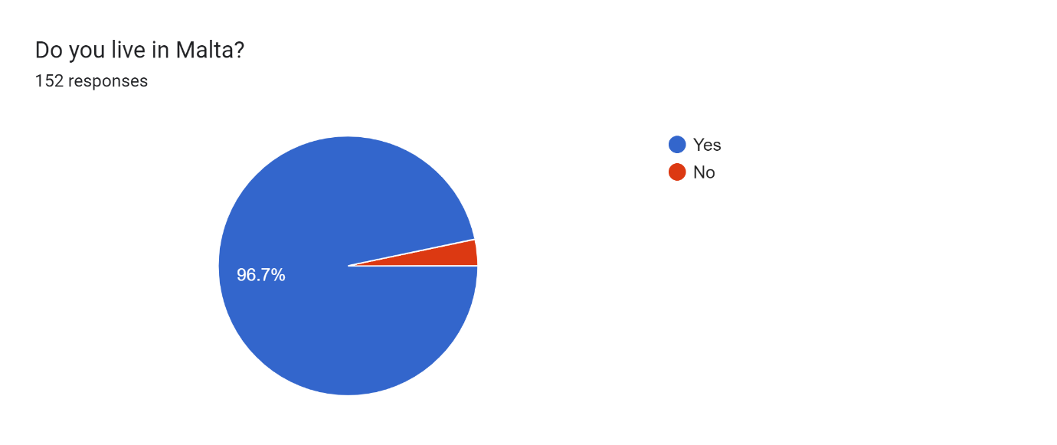

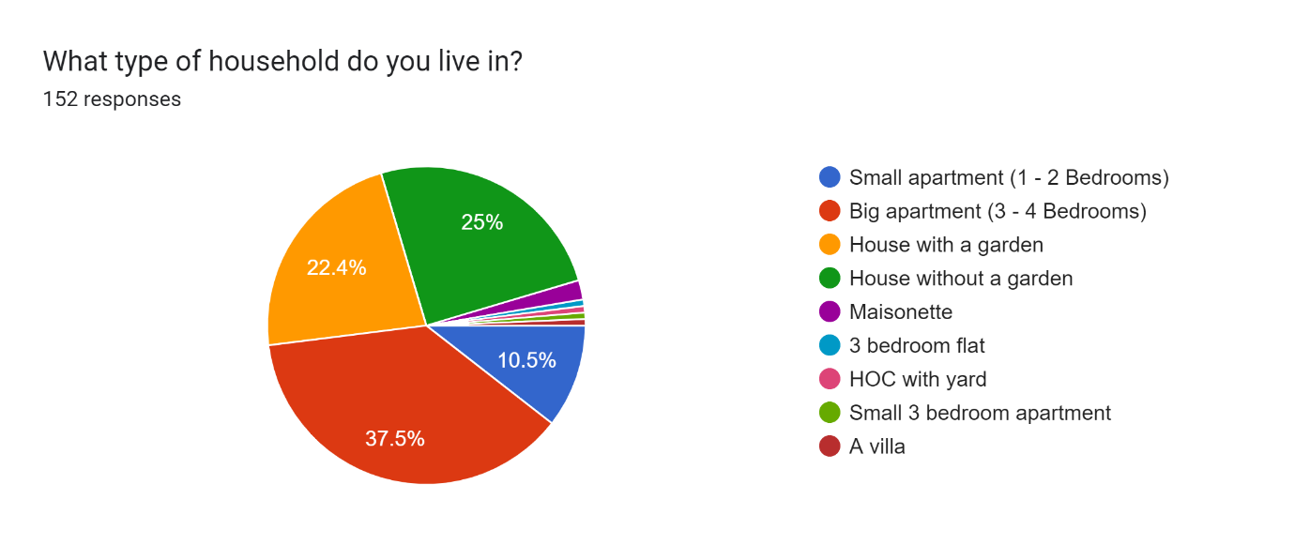

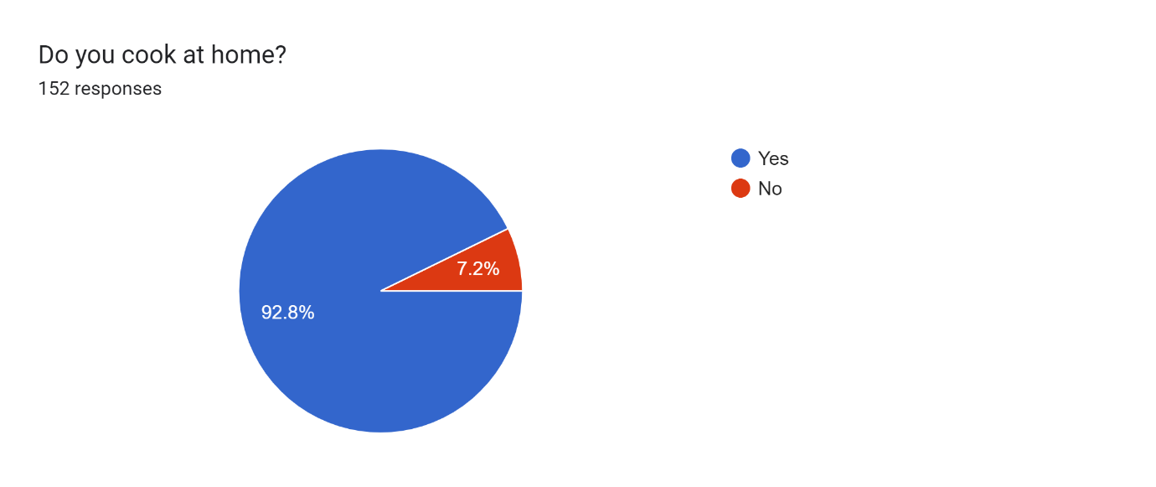

**Cooking at home option**

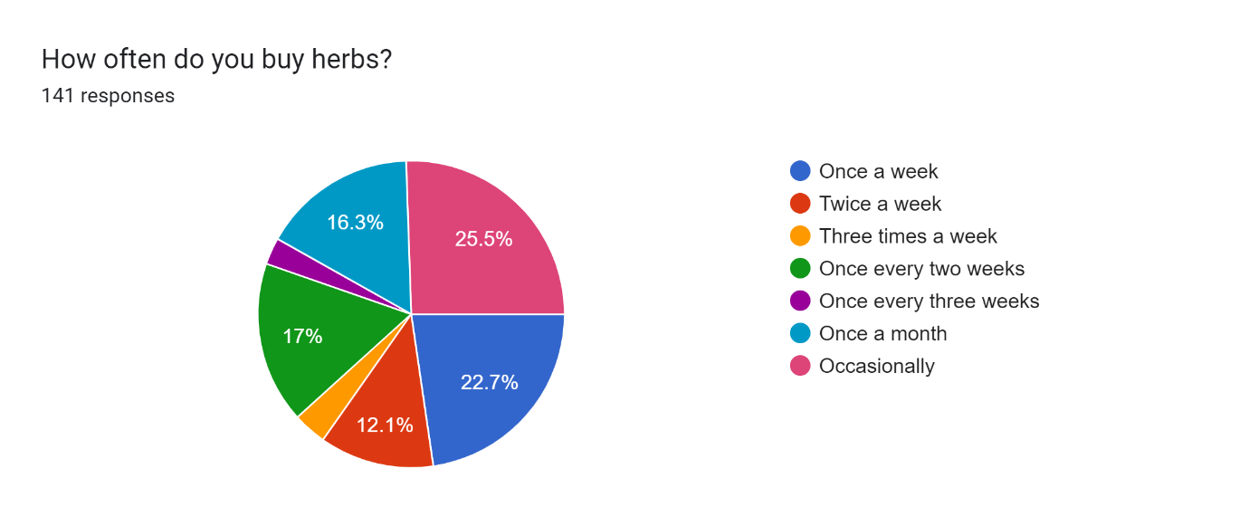

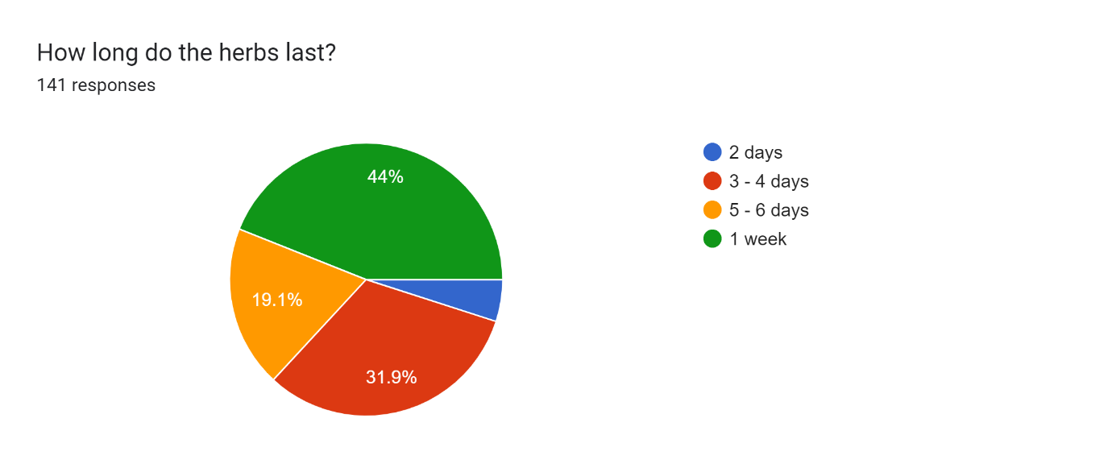

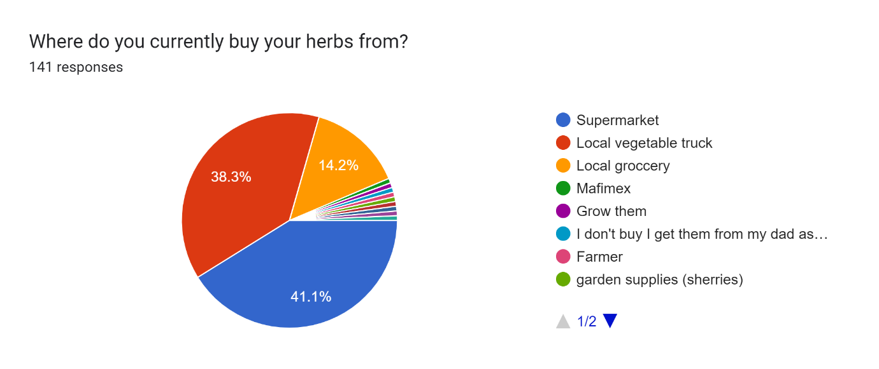

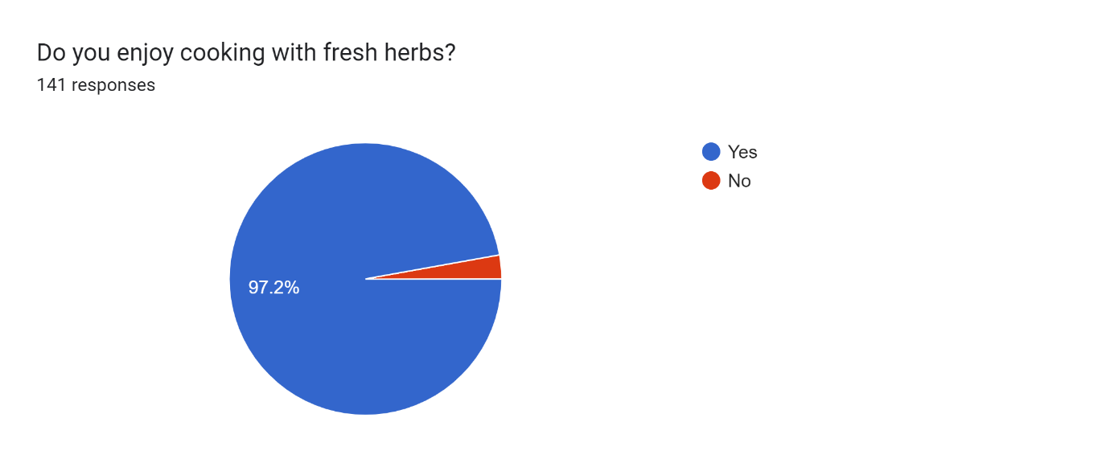

**Section 2**

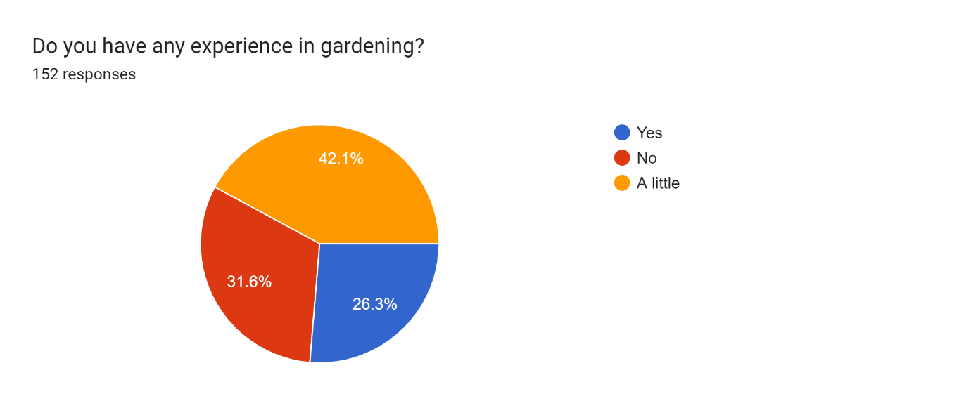

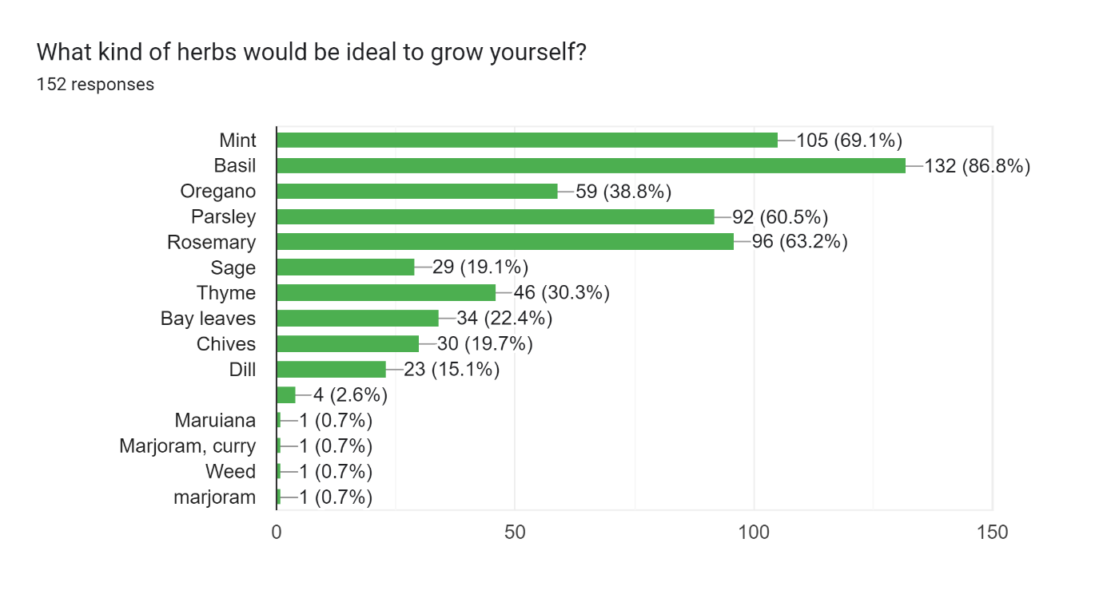

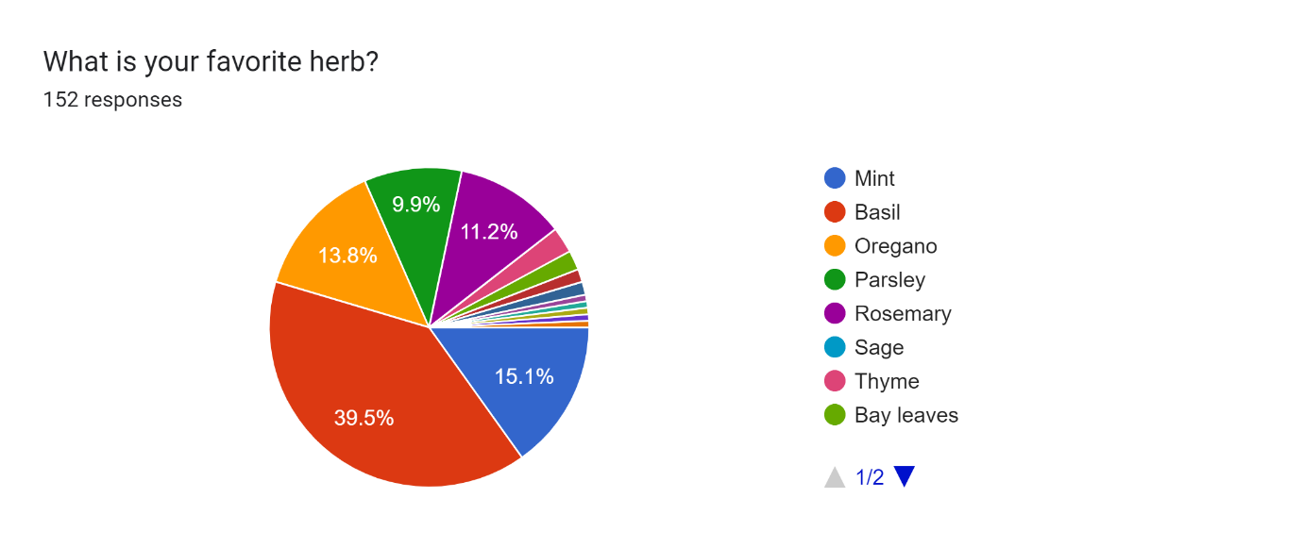

Forms response chart. Question title: Do you like the idea of growing your own herbs to use while cooking?
. Number of responses: 152 responses.

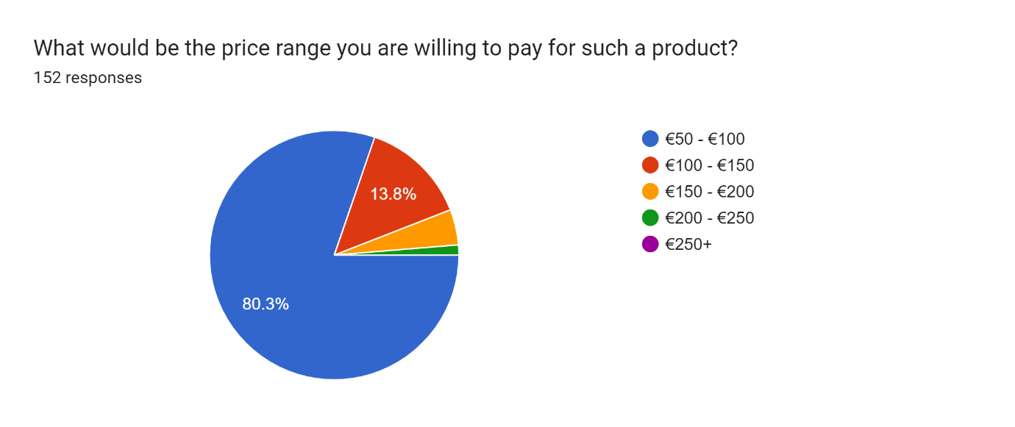

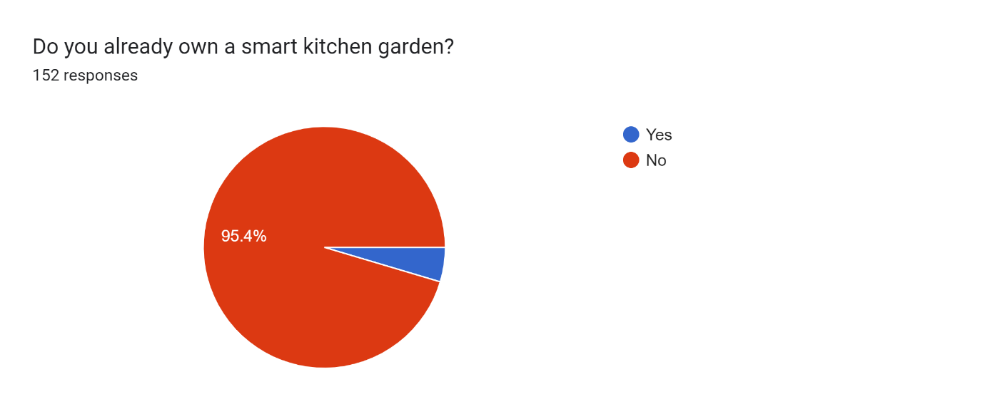

**Do not own a smart kitchen garden option**

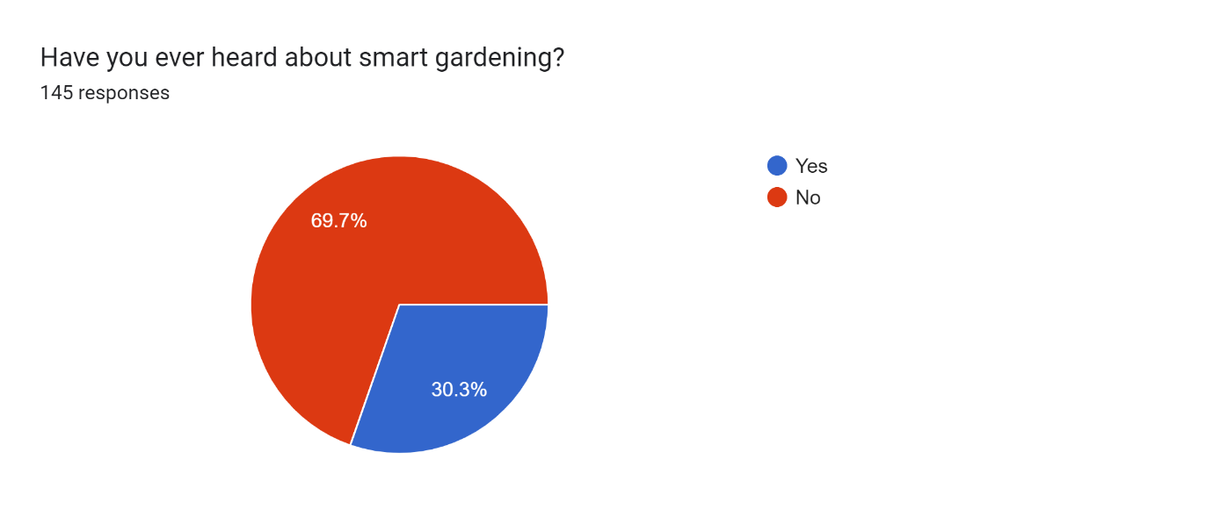

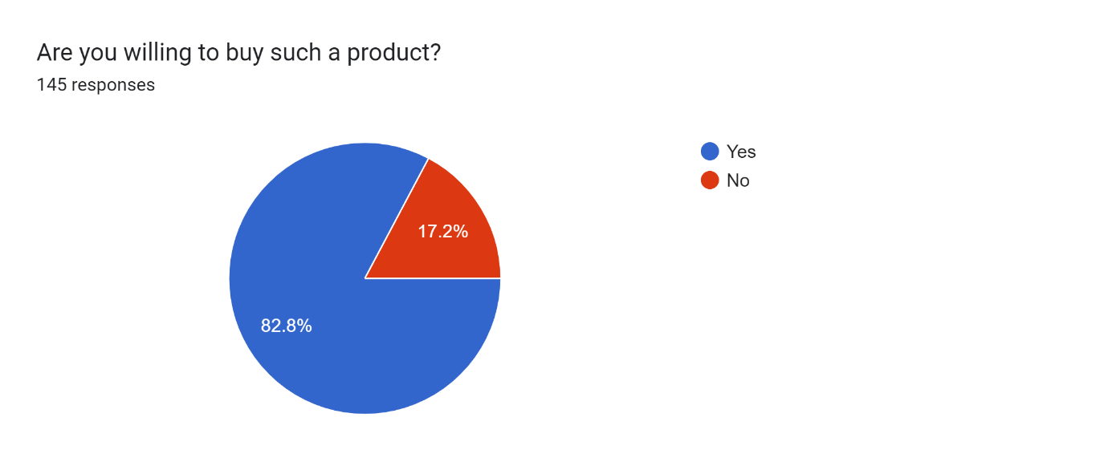

**Own a smart kitchen garden option**

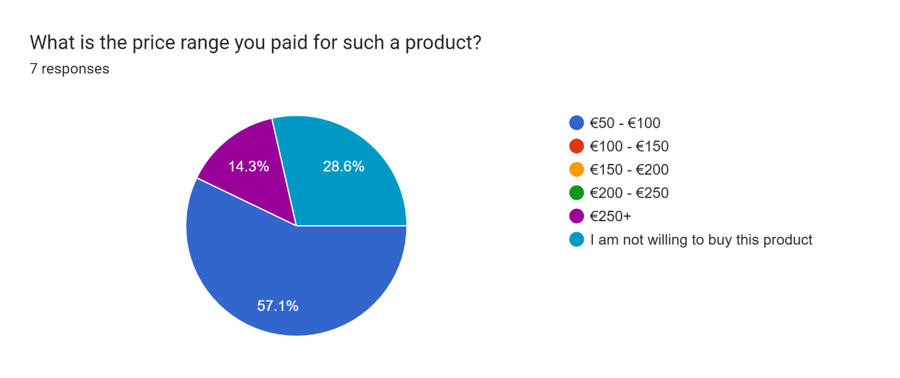

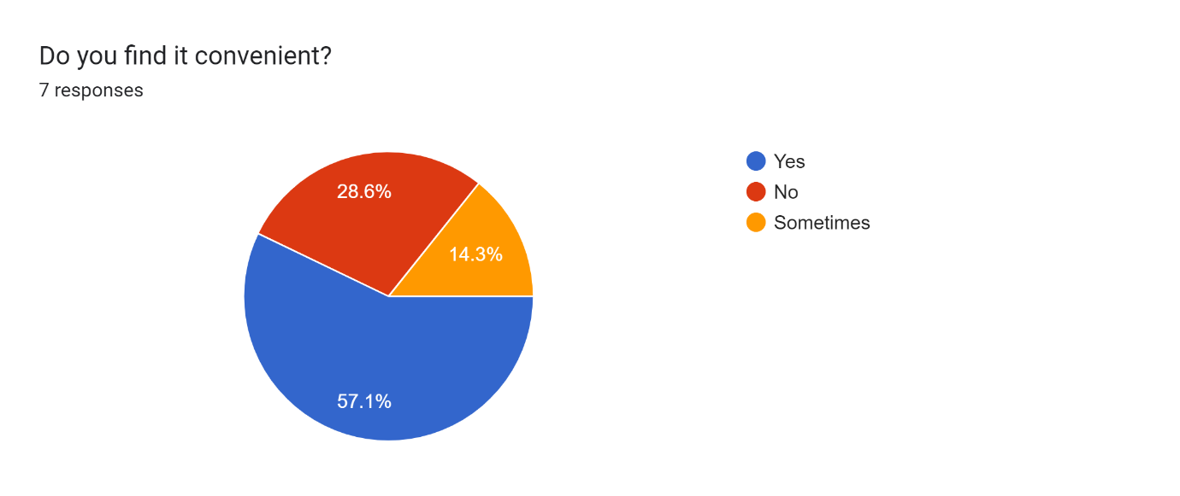

**Section 3**

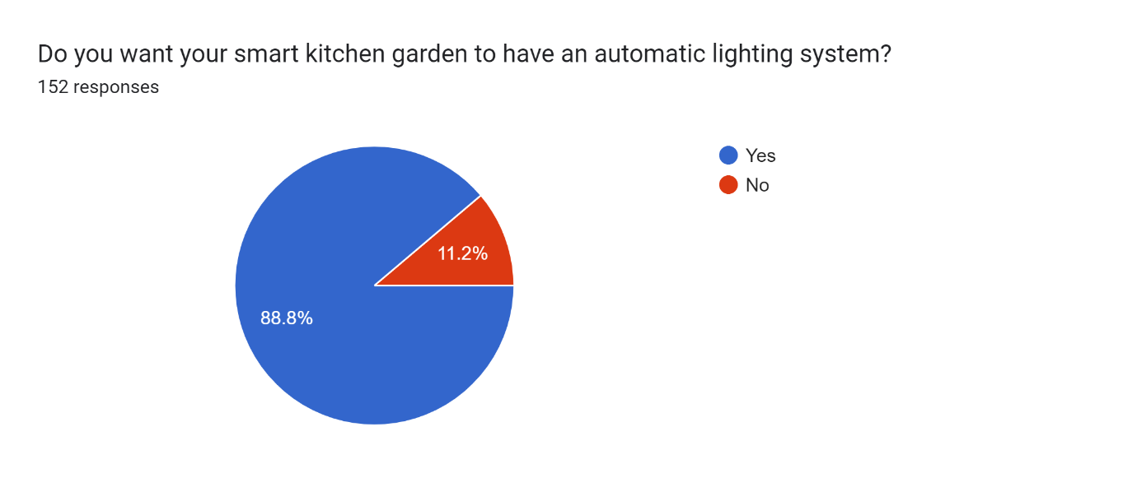

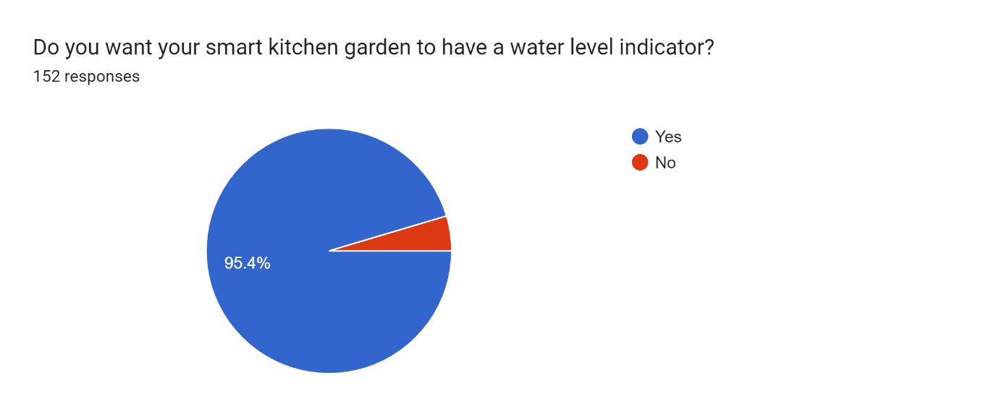

## 3.5 Interpretation of Research Results and Concluding Remarks

* “What is your age group?”

The highest age group with 29.6% that we collected is 16-24. Though for our product it makes more sense to target mature people or people who cook for themselves at home rather than a family member. Because of this we will be focusing on the older age groups (30 – 60+). These age groups combined total a percentage of 64.5%. These age groups are more likely to use our product whilst cooking in their homes.

* “Do you live in Malta?”

96.7% that took this questionnaire are residents in Malta. Because of this, we have to base our product in Malta.

* “What type of household do you live in?”

10.5% live in a small apartment, 25% own a house but have no garden, and 37.5% own a bigger apartment. This concludes that 73% of the people who conducted the questionnaire do not own a garden, therefore this confirms that this is the market gap we need to focus on.

* “Do you cook at home?”

92.8% that filled in the survey mostly cook at home. This is also part of the market gap that we need to aim at.

**Cooking at home option**

* “How often do you buy herbs?” & “How long do the herbs last?”

The average percentage that we gathered of which people buy their herbs is once or twice a week which means that our product will be cheaper overall since they will last longer. The highest percentage is 44% that states the herbs will last for 1 week.

* “Where do you currently buy your herbs from? “

From the looks of this question, we gathered that our main local competitors will be supermarkets with 41.1% and vegetable trucks with 38.3%.

* “What kind of herbs would be ideal to grow yourself?” & “What is your favorite herb?”

The responses to these two questions vary quite a lot, but the most popular herb that would be ideal to grow and is also favorite is basil. Mint, parsley, and oregano are also popular results. We will be focusing on selling these popular herbs.

* “What would be the price range you are willing to pay for such a product?”

80.3% of the people are willing to pay a price range of €50 - €100, and 13.8% are willing to pay a price range of €100 - €150. This means we need to focus on making our product affordable in these ranges.

* “Do you already own a smart kitchen garden?” & “Are you willing to buy such a product?”

95.4% do not own a smart kitchen garden. 82.8% of these people are willing to buy such a product. From these results, we see people seem interested in our product.

* “Have you ever heard about smart gardening?”

69.7% of the people who do not own a smart garden have never heard of such a product before. Because of this, we need to focus on marketing to spread the word about our product.

* “What is the brand name?”

Some people who filled in our questionnaire already own a smart garden. The most popular brand name is Click & Grow, which will be our biggest competitor.

**Section 3**

* “Do you want your smart kitchen garden to have an automatic lighting system?”, “Do you want your smart kitchen garden to have a water level indicator?” & “Do you want your smart kitchen garden to be portable/rechargeable?”

Most of the people who filled in the survey want their smart kitchen garden with an automatic lighting system, water level indicator, and rechargeable. This was expected as it is convenient for such features.

* “How many different herbs are ideal to grow in the same product at one time?”

The response to this question varies a lot, but the two most popular options are 3 and 4 slots. This means we will focus on these but will also have other options for cheaper or more expensive products.

# SWOT Analysis

**Strengths**

* Innovative product with potential for high demand
* Growing their own produce is becoming more popular among health-conscious consumers.
* Smart technology enables efficient and optimized resource utilization.
* Low environmental impact and promotes living sustainably.
* Customers can select from a variety of herbs and subscribe to receive pods monthly.
* Our product is not affected by the weather because it will be kept inside with automatic lighting.

**Weaknesses**

* Initial development and manufacturing costs are high.
* Low Brand Awareness therefore customers may choose other well-known brands.
* There is a lack of market share and brand awareness.

**Opportunities**

* Growing interest in organic and locally sourced produce
* Possibility of expanding into other markets for smart home technology
* Growing interest in eco-friendly living and lowering environmental impact

**Threats**

* Competition from established home garden brands and other smart home technology companies
* Sales and profitability may suffer if competitors offer comparable products at lower prices.
* There is a shortage of electronic devices, which could impact on our product production.
* Since it is a rapidly growing market, new competitors may be introduced

# Marketing Plan

## 5.1 Branding

Fig. 5 - Herb Garden Ltd. Logo

*‘The Joy of Fresh Herbs’*

We chose our logo to be a shade of green because our products focus on fresh natural herbs. The logo consists of 2 leaves. This is because our first prototype design holds 2 pods.

Our company is unique and different because of the features that we offer such as biodegradable pods to reduce the waste of plastic and we also offer an automatic timing system which makes it easy and comfortable for you to always leave on. Our devices come in a variety of sizes which makes it unique as every individual person can choose his own preference. People who own one of our products will have the opportunity to learn how to grow their own herbs and even be able to grow their favorite herb at any time of the year.

To gain our customers' loyalty, we must be loyal to them first. We will listen to our customers' feedback, use their feedback to improve our business and products, then we will inform our customers that we heard them, and finally have explicitly implemented their solutions to give them the best experience possible.

## 5.2 Monthly Marketing Budget

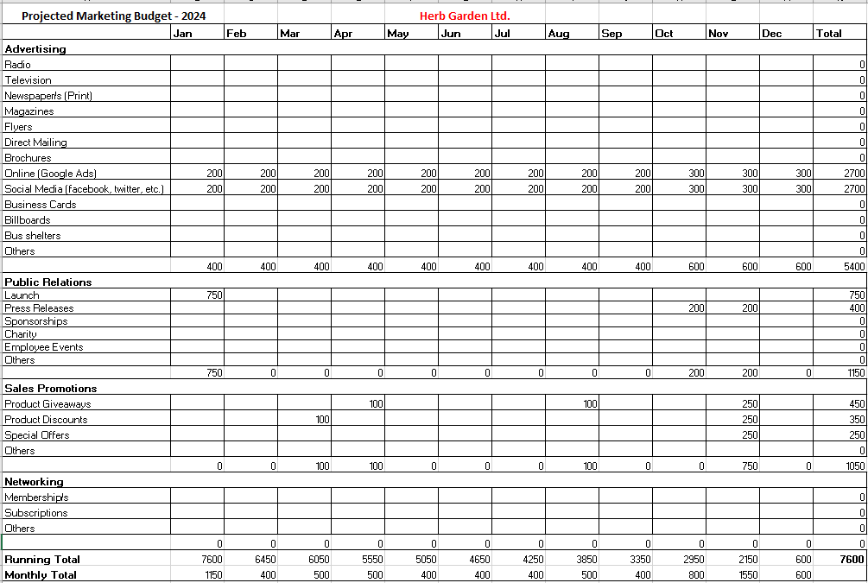

Fig. 6 - Marketing Budget

## 5.3 Pricing Strategy

**Products Pricing**

To produce the shell of our products, we will be subcontracting a 3D Printing company to print our devices at a cost as shown below in the table, row ‘Printing Cost’.

As shown in Fig. 6, the product is fairly cheaper than our main competitor Click & Grow. All factors were considered to make it more affordable for our customers.

Fig. 5 shows our 5 main products, which are a smart kitchen garden with a variety of sizes. Each one contains a price according to its size, price of electronics and pods/plants used, whilst also containing the cost of printing from the sub-company. The price of each device was then added with a markup percentage in such a way that a profit can be made. Finally, 18% VAT was added to these products.

Fig. 7 – Herb Garden Ltd. device prices

Fig. 8 - Click & Grow device prices

**Pods Pricing**

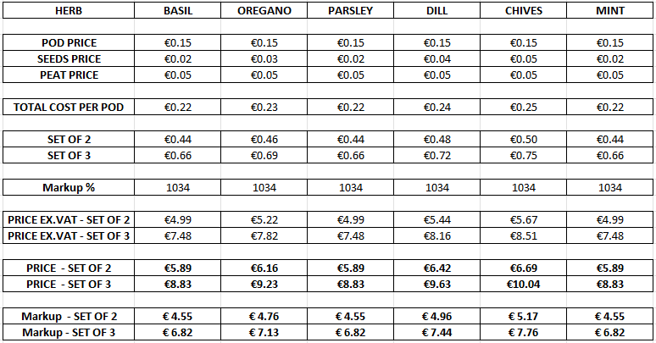

Fig. 9 - Herb Garden Ltd. herb prices



Fig. 10 - Click & Grow prices per herb pod

## 5.4 Physical Location and Distribution Channels

Since we are planning to open an online marketplace, we will need a store where we can develop our products and take orders. Although one of us already has a garage that they do not use, we have chosen to arrange it to a manufacturing garage so that we may work there.

An online marketplace would be one distribution method for our smart kitchen garden, where clients could buy from our online website and have our product delivered from the comfort of their own homes.

Through our online store, we have implemented a direct-to-customer sales model. We provide customers with the option of purchasing our Smart Kitchen Garden directly from us by leveraging the power of e-commerce. Our online store has an easy-to-use interface, detailed product information, secure payment options, and fast shipping.

## 5.5 Promotional Plans

We will create a social media campaign that will include Facebook, Twitter and Google ads targeting users interested in organic and sustainable food, as well as apartment owners. We will also run an email marketing campaign that will target customers who have expressed an interest in similar products. We will allocate additional resources to intensify our promotional activities during the months of October, November, and December. This period presents an ideal opportunity to capture the attention of potential customers who are seeking innovative solutions for their indoor gardening needs and gift-giving ideas for the holiday season.

In addition, we will form partnerships with health and wellness influencers to promote our smart kitchen garden products through sponsored posts and other social media activities including giveaways to increase brand awareness and reach.

To increase sales, we will also offer a limited-time discount on first-time website purchases. Throughout the year, we will also hold three Smart Kitchen Garden giveaways. Customers will have the opportunity to win our innovative product, allowing them to experience the convenience and benefits of homegrown produce. Customers who participate in our giveaways will not only have a chance to win the Smart Kitchen Garden, but they will also gain access to exclusive content and promotions. Our website and social media channels will be used to promote the giveaways, ensuring maximum participation and engagement.

Furthermore, we will create videos, tutorials, and blog posts that will be featured on our Facebook page and YouTube channel, highlighting the features and benefits of our smart kitchen garden. These will include videos of the garden in action, growing and harvesting tips, and recipes that incorporate garden's produce.

To support the successful launch of our product, we have allocated a budget of €750 for promotional activities. This investment will be spread across multiple channels, such as social media advertising, online platforms, and other marketing initiatives. By strategically allocating these funds, we aim to maximize our reach and raise awareness among our target audience about the innovative features and benefits of our Smart Kitchen Garden.

We will track engagement rates, website traffic, and sales data to continuously monitor and measure the effectiveness of our promotional activities. We will then use this information to continuously improve our strategies and ensure that we are effectively reaching our target audience.

# 6.Organisation

## 6.1 Business Legal Format

Our legal structure is a Limited Liability Company (Ltd). This was chosen because it provides the owners with personal liability protection, flexibility in management and taxation, and credibility.

## 6.2 Organization Chart and Key Responsibilities

Fig. 11 - Organization Chart

# 7. Operating Plan

## 7.1 Development Timeline

Fig. 12 - Gantt Chart

## 7.2 Operations Flow

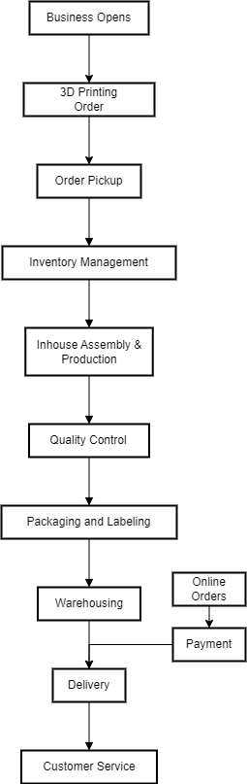

Fig. 13 - Operations Flow

## 7.3 Resources Required

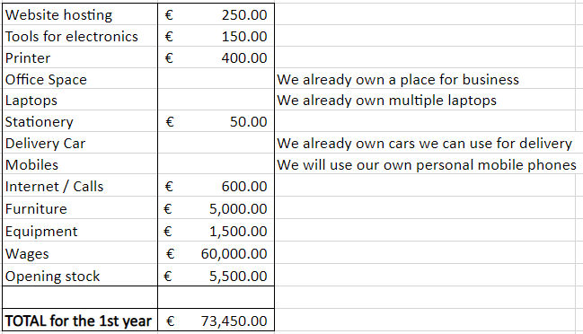

Fig. 14 - Resources Required for the first year

# 8. Financial Planning

## 8.1 Sales Forecast

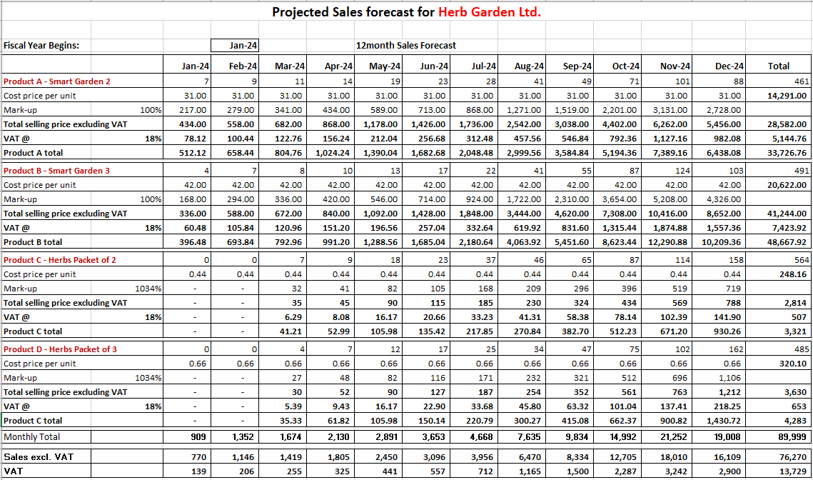

Fig. 15 - Sales Forecast

## 8.2 Cash Flow Forecast

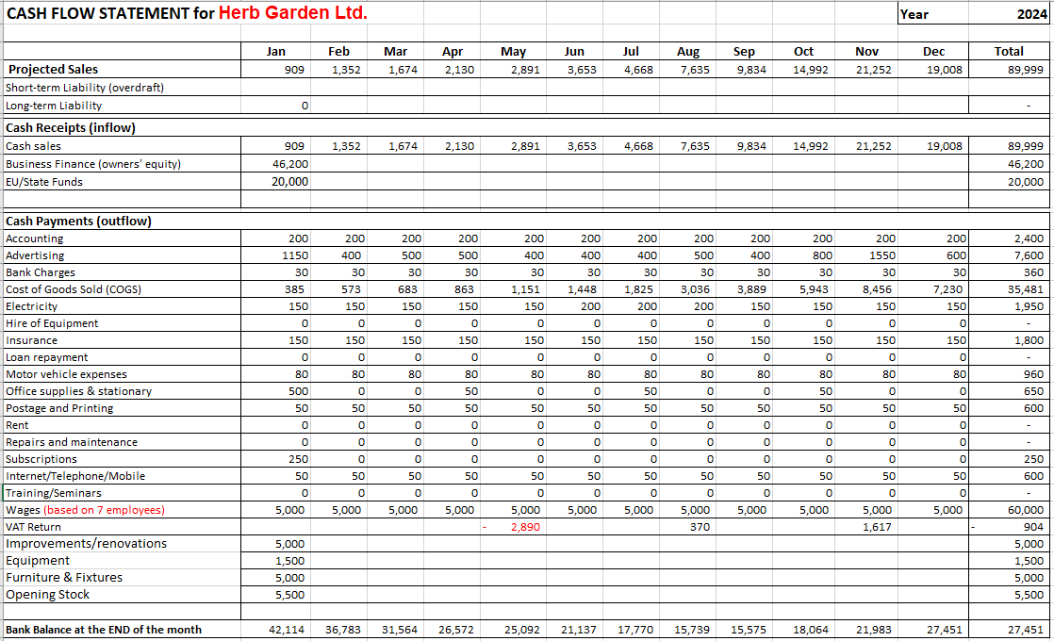

Fig. 16 - Cash Flow Forecast

## 8.3 Funding Requirements

Fig. 17 -Funding Requirements

# 9.Appendices

## 9.1 Questionnaire / Interviews

## 9.2 Quotations for Resources Required

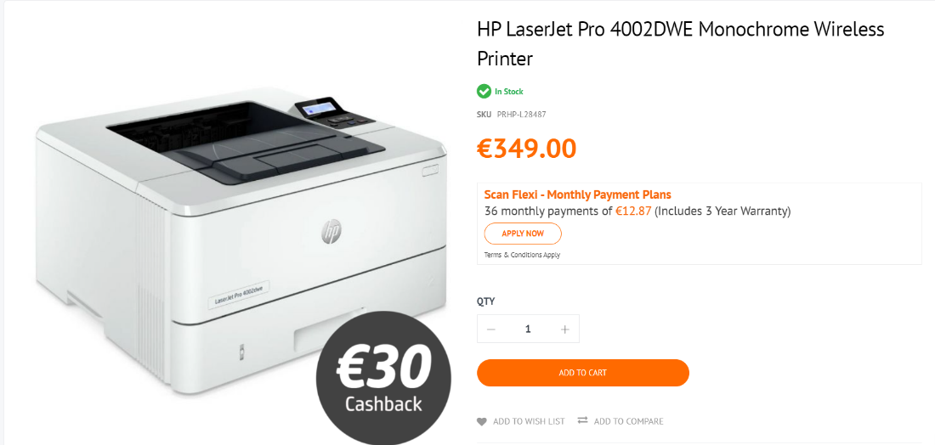

Fig. 18 - Scan Malta printer Malta

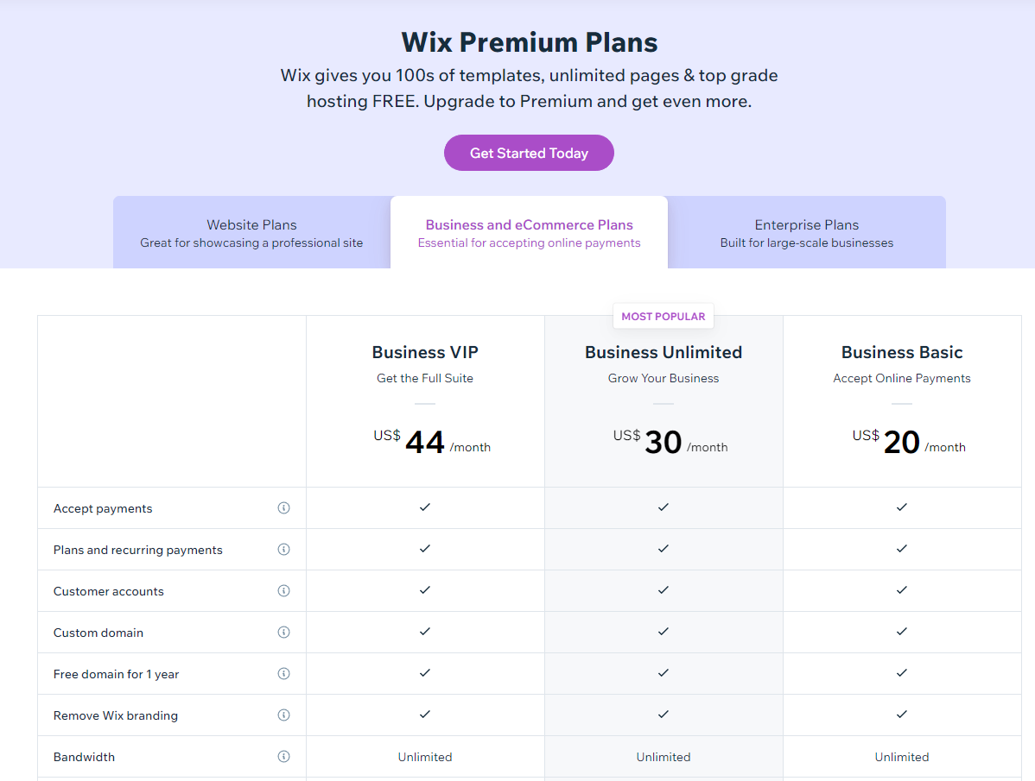

Fig. 19 - Wix prices (Website)

Fig. 20 - Multi Packaging Ltd Prices

## 9.5 Other

**Table of Figures**

Fig. 1 - Exploded View of Prototype 5

Fig. 2 - Smart Kitchen Garden Model 5

Fig. 3 - Assembled Product 6

Fig. 4 - Assembled device with plants 6

Fig. 5 - Herb Garden Ltd. Logo 24

Fig. 6 - Marketing Budget 25

Fig. 7 – Herb Garden Ltd. device prices 26

Fig. 8 - Click & Grow device prices 26

Fig. 9 - Herb Garden Ltd. herb prices 27

Fig. 10 - Click & Grow prices per herb pod 27

Fig. 11 - Organization Chart 29

Fig. 12 - Gantt Chart 30

Fig. 13 - Operations Flow 31

Fig. 14 - Resources Required for the first year 32

Fig. 15 - Sales Forecast 33

Fig. 16 - Cash Flow Forecast 34

Fig. 17 -Funding Requirements 35

Fig. 18 - Scan Malta printer Malta 45

Fig. 19 - Wix prices (Website) 45

Fig. 20 - Multi Packaging Ltd Prices 46

# 10. References

*Click & grow.* [Online]   
Available at: https://eu.clickandgrow.com

*EN 13432:2000. Packaging - Requirements for Packaging Recoverable Through Composting and Biodegradation - Test Scheme and Evaluation Criteria for the Final Acceptance of Packaging, European Committee for Standardization.* [Online].

*Veritable.* [Online]   
Available at: https://www.veritable-potager.fr/en/